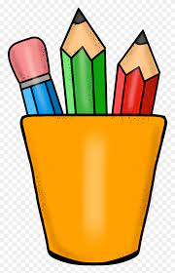

Sixth Grade Supply List
Backpack
Pencils
Pencil sharpener
Dry erase markers
Water bottle
Pair of scissors
Box of crayons
Box of colored pencils
Pack of erasers
Headphones
Glue sticks
Folders
Four - single subject notebooks
One - composition notebook
Index cards

Classroom Supplies
Box of tissues
Papertowels
Wipes

Optional
Box of Markers
Water Bottles

